Kyle to do list:
- Copy paste end of chapter bullets
- Read new cannabis papers
- Add in replacement images (Punja/Gauthier/etc)
- Review chapters and complete new new image permission
- Email asking for permission for any needed images Ch 15
- Review and edit chapter 8
- Ch 8 add image of endophyte transmission (padney et al 2022)...emailed 8/28
- Read/review/edit sections 1,2,3,4
- Ch 11 add image of cannabis virus SEM
- Finish section 3&4 image addition/permission
- Chapter 12 add diagram of pm lifecycle
- Make a list of images from Punja, White,Volk, etc and anyone else that granted permission
  - Add source pg and fig#
- Add info on infection cushion ch 13,14,15, 16
- Ch 14 image of oomycete vs true fungus
  - If cannot find image at least make sure to describe difference or create a table
- Ch 15 Find usable life cycle for fusarium and verticillium…replace image 15.3 fusarium life cycle
  - Email/call APS to ask for permission on images, called APS 10/21 and left message for Sue
- Ch 15 add images for verticcilium and Athelia rolfsii and macrophomina
- Section 3: Sclerotinia rolfsii, Fusarium oxysporum, Golovinomyces ambrosiae, Rhizoctinia solani, Septoria cannabis life cycle?
  - Can we use someone from Fiverr to create lifecycle diagrams?...messaged 2 artist on fiverr 10/23
  - Carlson Stock Art Disease diagrams
- Ch 18 add picture of dry moldy flower not on living plant
- Ch 19 figure 1 description
- Ch 22 difference between solarization and steam pasteurization
- Ch 23 image of trichodema parasitizing other mycelium…punja
- Create updated image spreadsheet
- Look into using biorender to recreate lifecycles and diagrams…$80/month for 1 user
  - Or use artist through Fiverr
- Email Ch 15 images
- Move completed sections to V2.0 folder
- Redo Fig 19.3 Zigzag model
- Redo Fig 24.1 endophyte potential applications
- Ask Sean Collins for cannabis pathogen pictures
- Respond Dr Nicole Gauthier
  - PM chasmothecia,
  - verticcilium wilting symptoms
  - Atelia disease symptoms
  - Macrophomina symptoms
- Create table for stage of plant growth (cutting veg/seedling/flowering/etc) and pathogen susceptibility
- Create draft email to send to potential editors
  - Compensation of $30-50 per hour, 0.01 per word
- Can AI edit manuscript?... Too long for Chat GPT, is there a different AI source we could use?
- Add section about mycotoxins in final product
- Add callout for mycobiome section 1
- Maya Albert for cannabis diagrams? (gwinn et al 23) email Gwinn @ kgwinn@utk.edu about Maya Albert and fig 1 Gwinn et al 2023…emailed 10/18
- Reach out to diagram illustrator (Carslon stock art)...https://www.carlsonstockart.com/photo/powdery-mildew-cannabis-leaves-311/…emailed via website 10/15/24 & 10/23/24
- Fig 12.5 and 19.5
- Create list of APS life cycles we would like to use (See above)
  - PM-purchased Carslon stock art
  - Budrot-Mahmoud et al has good diagram (punja author on paper)
  - Damping off
  - Crown rot
  - Hemp canker
  - Leaf spot
  - Fusarium
  - Sclerotina
  - Verticillium
- Ch 5 define convergent evolution
- Table 11.2
- Create list of acronyms used
- Create glossary with terms
- Add works cited section
- Decide on fiverr artist
  - Life cycle diagrams
- Purchase image from Carlson

Image replacement

Section 1
Ch 3 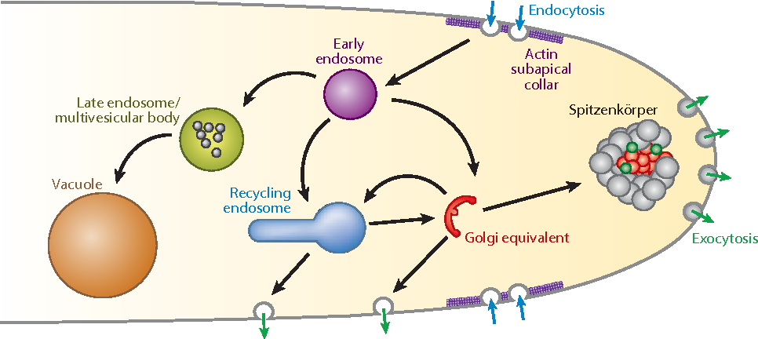
Figure 3.2. Growing fungal tip secretes enzymes and releases them into the environment (exocytosis) and then transporting smaller molecules back into the hypha for growth (endocytosis). (Riquelme 2013).

Section 2
Ch 8 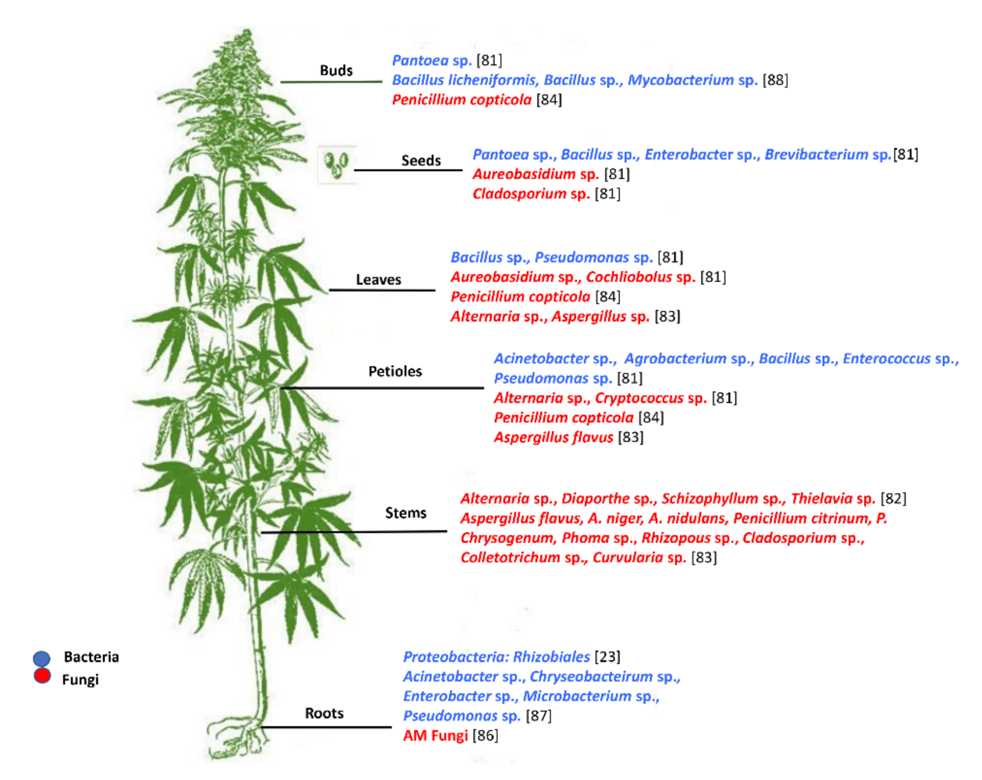
Figure 8.1 Endophyte species found in different parts of Cannabis plant (Taghinasab and Jabaji 2020). Emailed in July (no response) emailed again 10/18

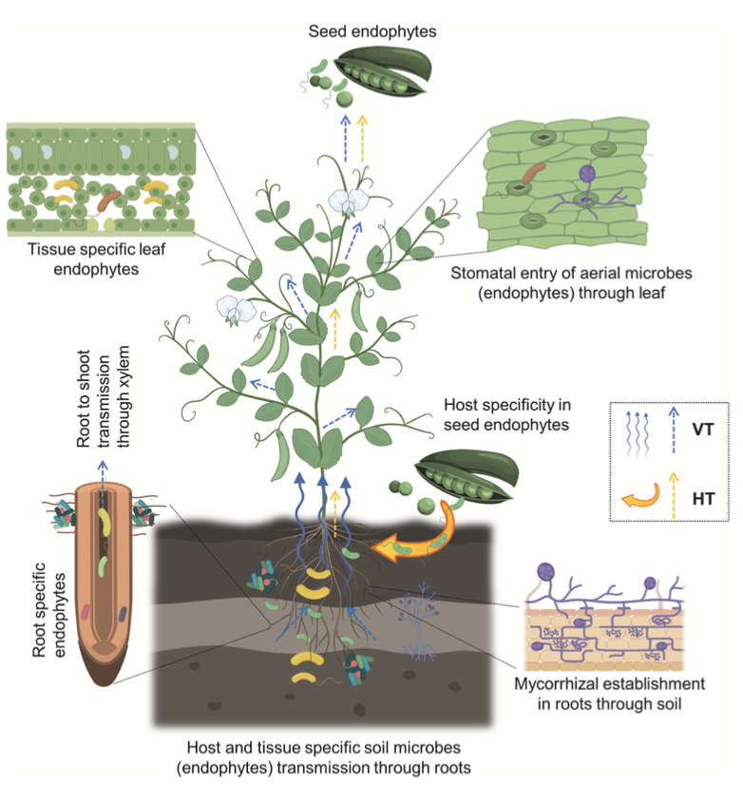
Figure 8.2. Examples of endophyte transmission in plants. (Padney et al 2022)...emailed padnney 8/28 and kumar 10/18

Section 3

Ch 17 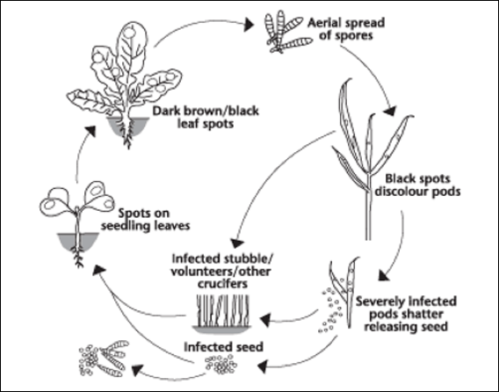
Figure 17.2. Disease life cycle of a typical leaf spot fungus. From https://www.canolacouncil.org/canola-encyclopedia/diseases/alternaria-black-spot/

Section 4
Ch 19 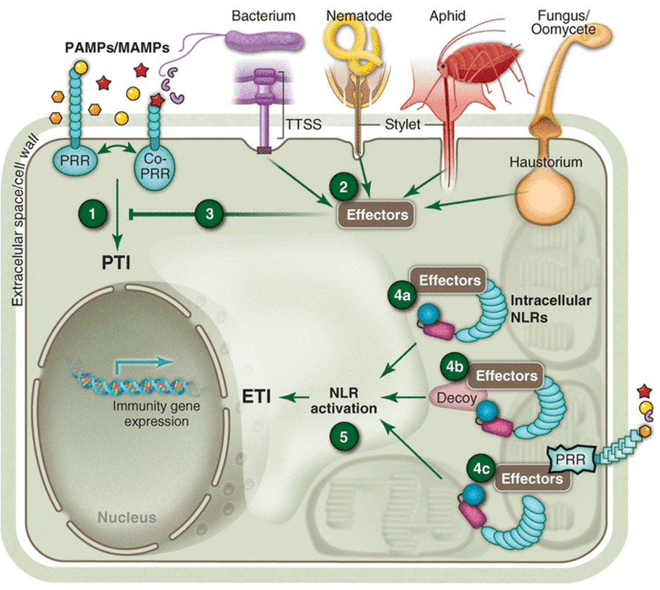
Figure 19.4. Diagram of plant immune system elicited by various effectors leading to increased expression of particular secondary metabolites. (Dangl et al 2013).

Review

